**Project # 1**

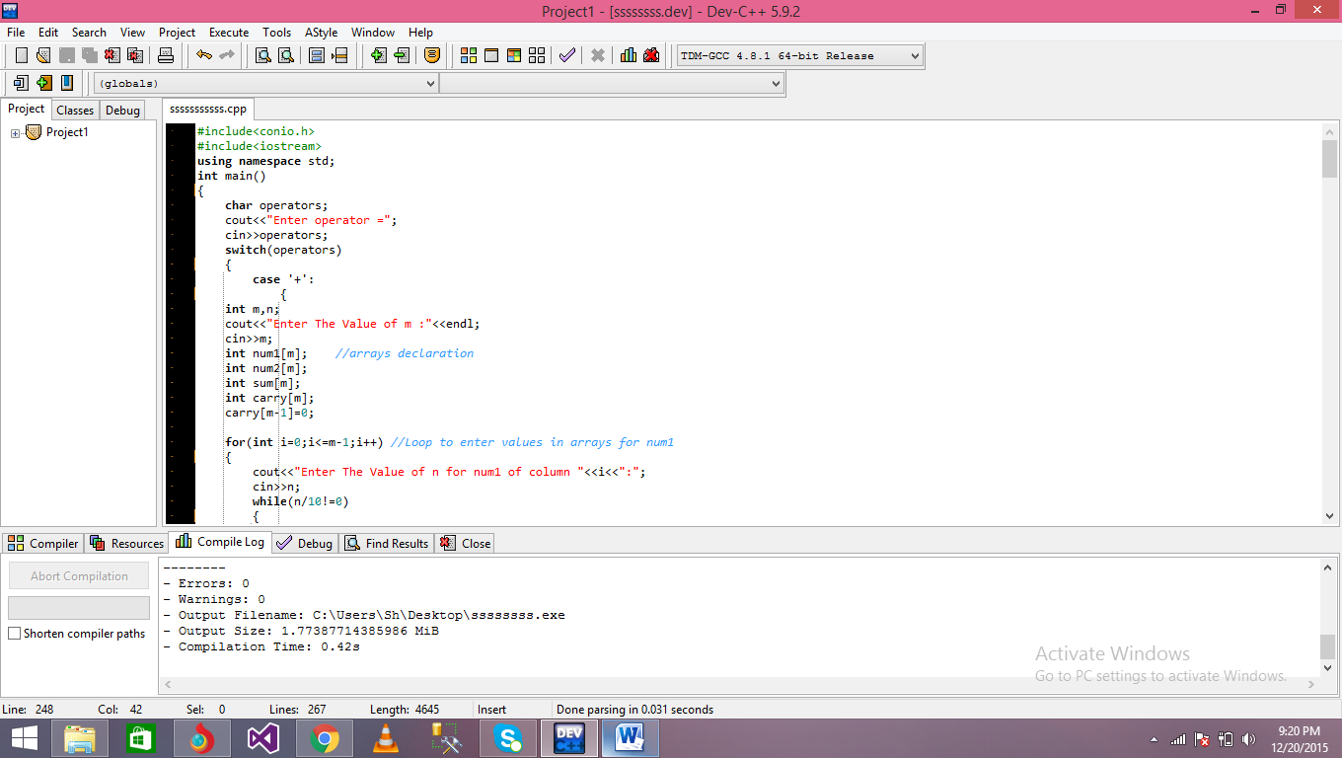

In the start of the program variable is declared of name operators.

Then compiler asked the user to input the operation you want to calculate.

When the user input the operator then the switch statement start

In 1st case :

Variable m,n is declared .

M is used for maximum size of array.

Then compiler asked the user to enter the value of m.

Then 4 arrays is declared of size m.

Num1 , num 2, sum and carry is declared.

Last index of carry array is always 0.

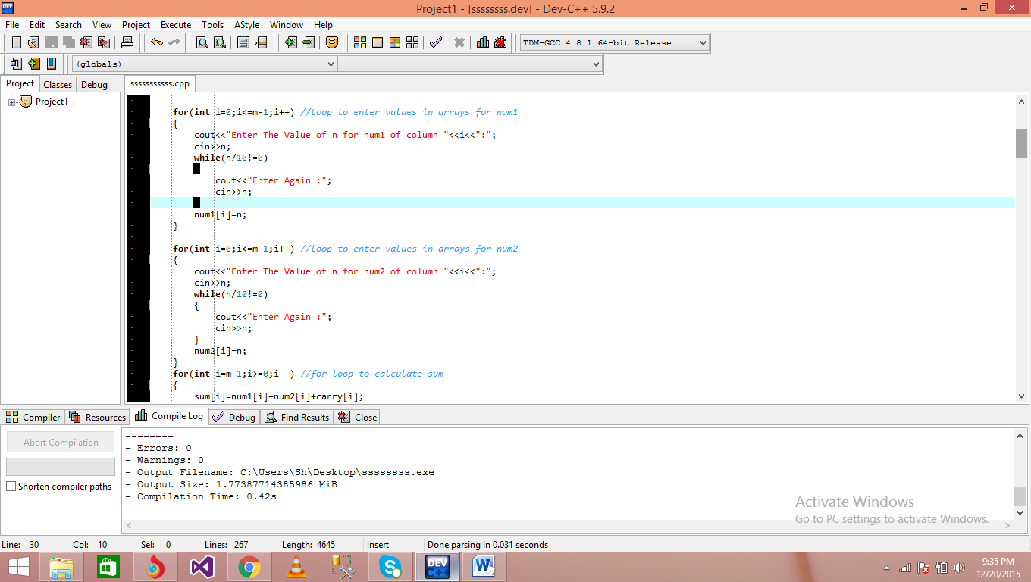

Now for loop is used to fill the index of num1 and num2.

In this loop compiler asked the user to enter the value of n.

In while loop :

We use n variable to check the num entered by user that num is less than 10 or not.

If num is greater than 10 then compiler asked the user enter again the value of n until n <10.

Same method is already used for num2.

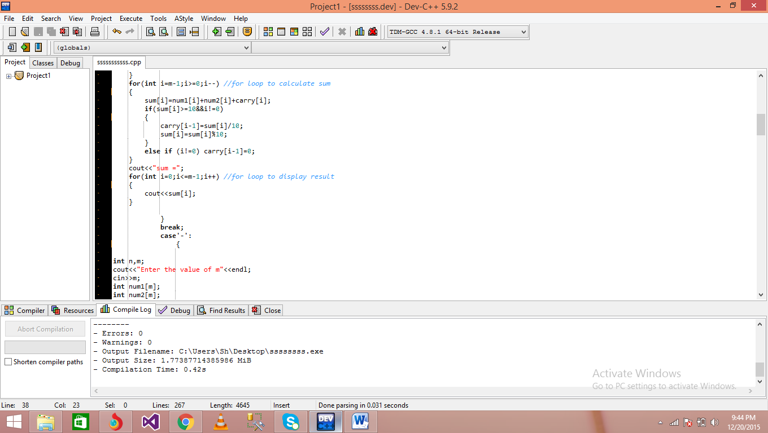

Another loop is start in which calculations take place.

In this loop sum is calculate.

Different logic can be used to calculate sum.

In the end last loop is used for display results which are saved in sum array.

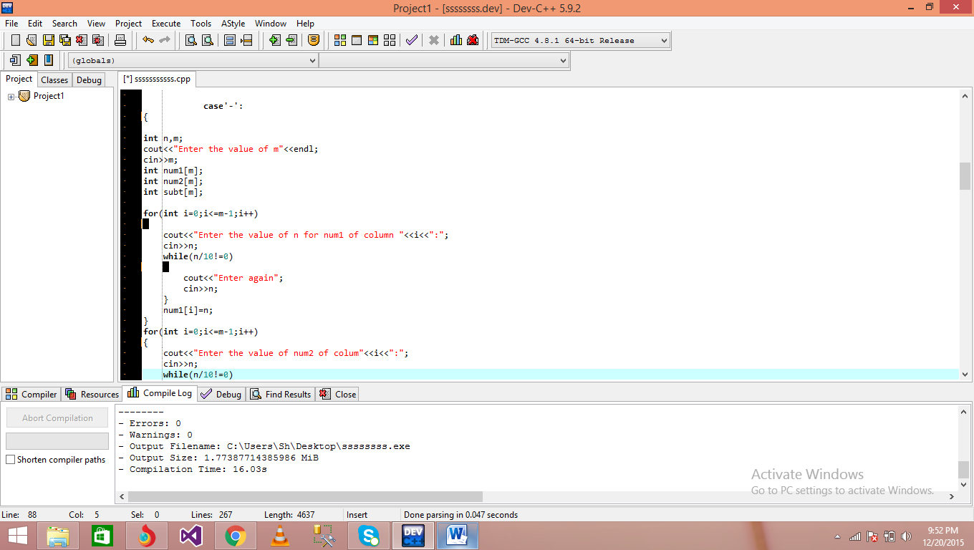

In 2nd Case :

In this case compiler calculate the subtract of two num.

M and n is also used in this case for same purpose.

Three arrays can be declared of size m.

For loop is used for fill all the index of num1,num2 by same method which are used in 1st case.

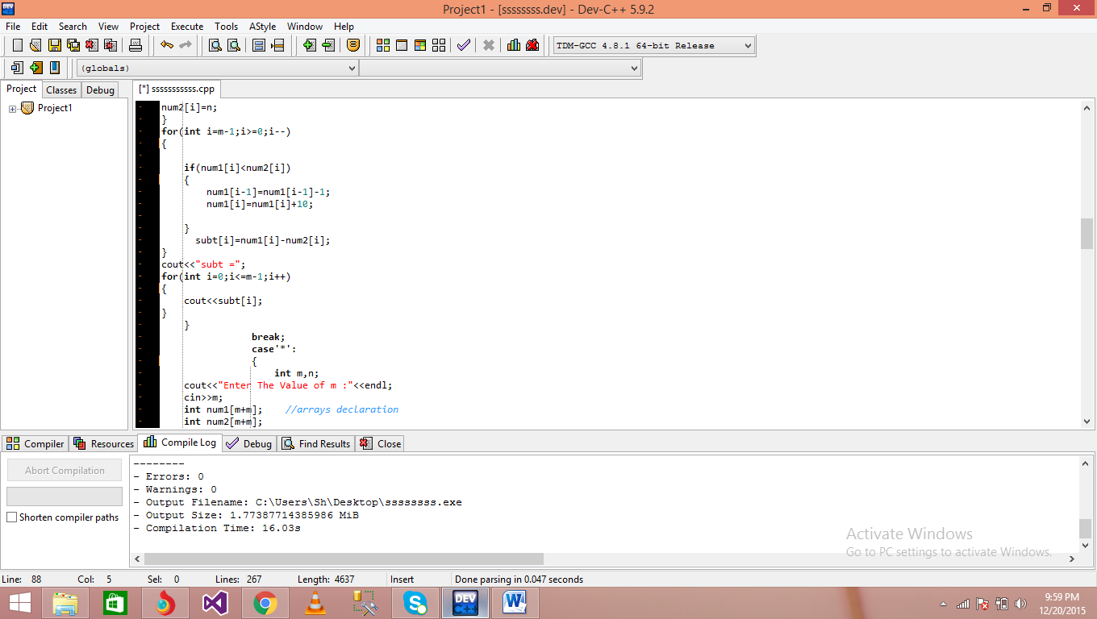

In next loop all calculations of subtract occurs.

For loop is used to calculate subtract of num1 , num2.

In the end for loop is used to display the result which is saved in subt array

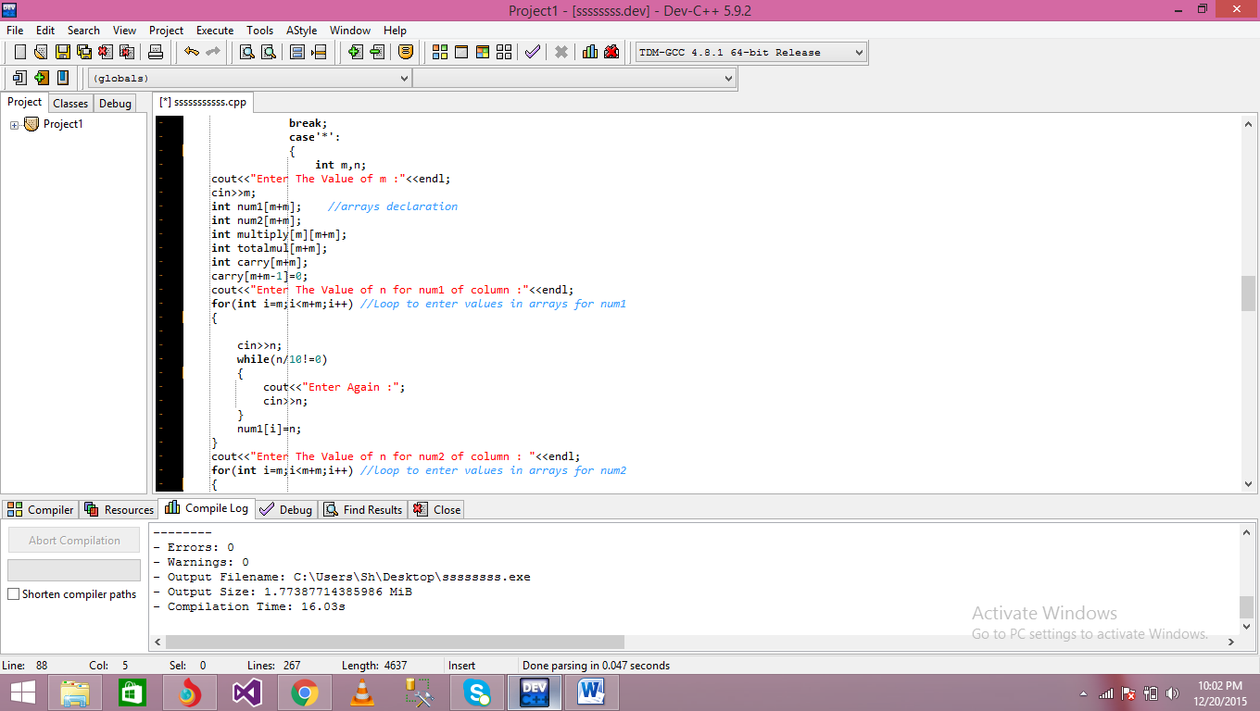

In 3rd case :

In this case multiplication of num1,num2 occurs.

M and n is also used in this case for same purpose.

Five arrays can be declared of size m.

Num1,num2,multiply,total_mul,carry are the following arrays of size m.

For loop is used for fill all the index of num1,num2 by same method which are used in upper cases.

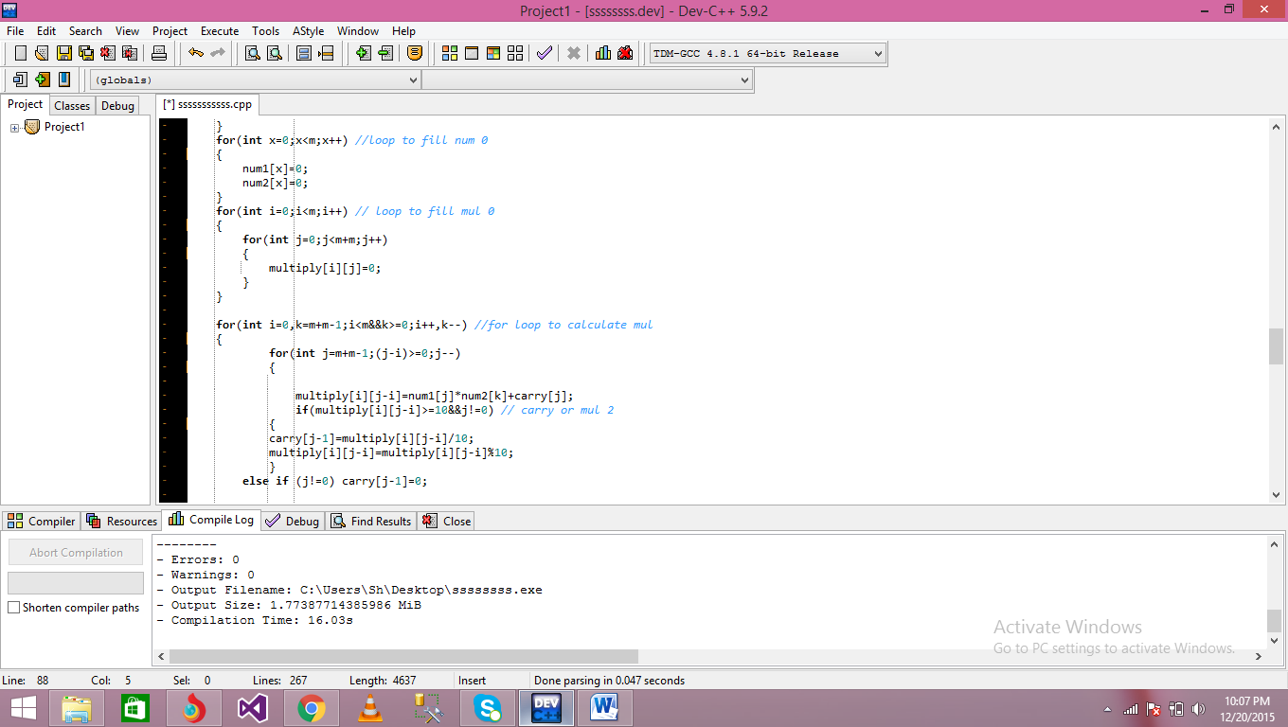

For loop is used to fill the extra index of num1 , num2 .

Another for loop is used is used to fill all the index of multiply array.

The main for loop start in which all calculation occurs.

In this loop num1 , num can be multiplied.

Different logics are used in this loop.

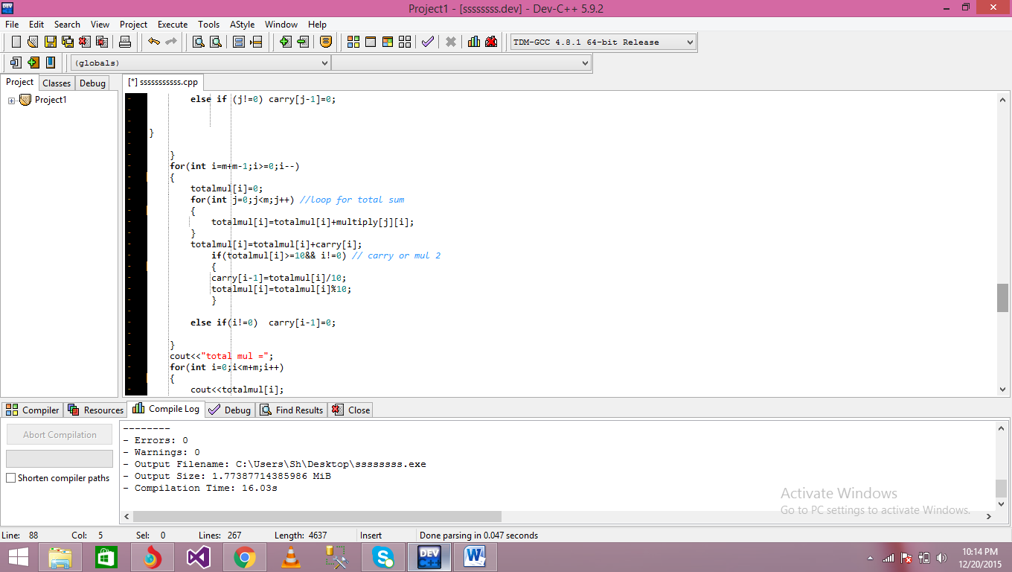

Another loop start in which we calculate sum of column of multiply array and saved into total mul result.

In the end another forloop is used to display result which are saved in toal mul array.

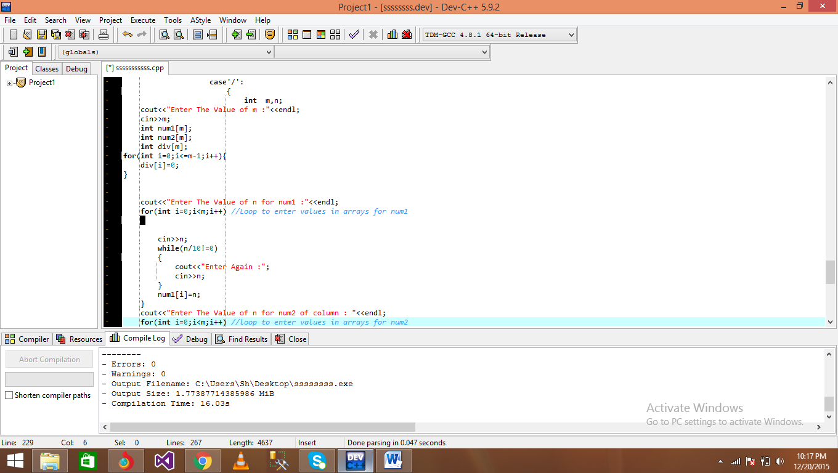

In 4th Case :

In this case compiler divide num1,num2.

M and n is also used in this case for same purpose.

Three arrays can be declared of size m.

Num1,num2,div are the following arrays of size m.

For loop is used for fill all the index of num1 , num2 by same method which are used in upper cases.

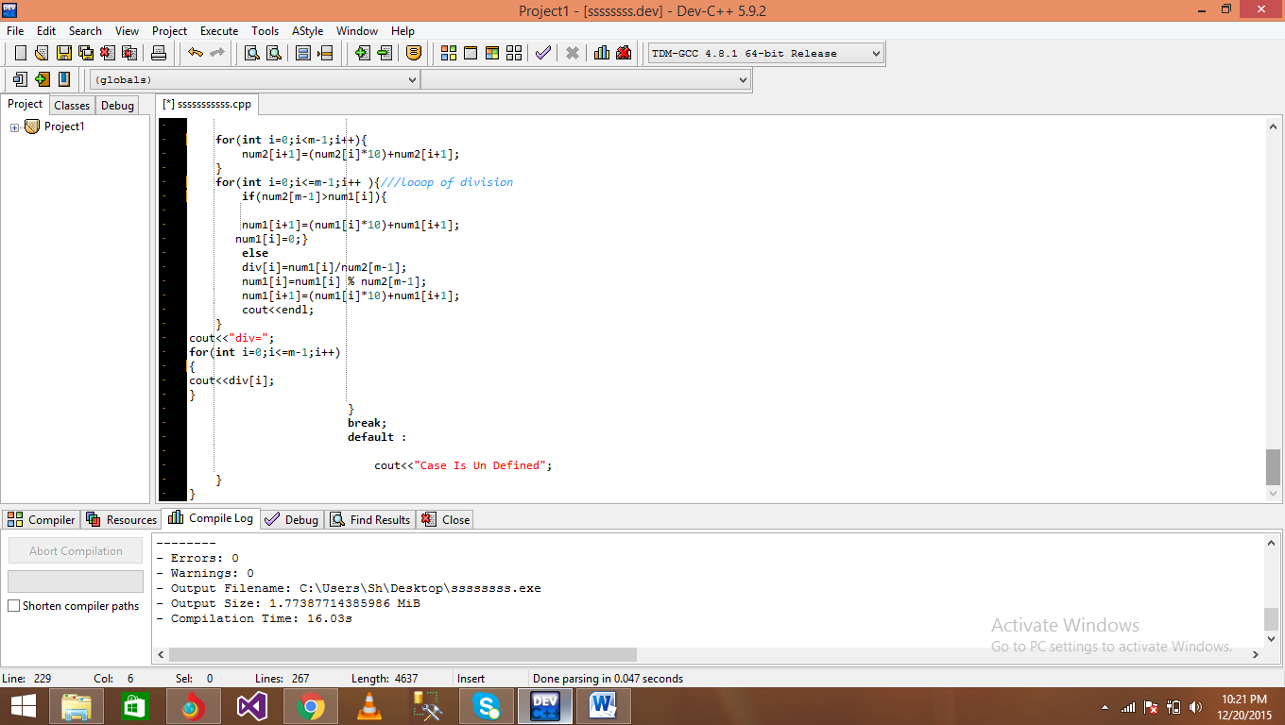

for loop is used for combile all the values of num2.

In Next loop division of num1,num2 take place which are saved in div array.

All division calculations occurs in this loop.

In the end the for loop is used to display result which are saved in div array.